# 

# **2023 STEM Girl Power Camp - Student Applications**

# Frequently asked questions (FAQs) and Instructions for applying

# What is the STEM Girl Power Camp?

The study and practice of science, technology, engineering and mathematics is collectively known as STEM. The seventh annual STEM Girl Power Camp is an initiative of [*Advancing education: An action plan for education in Queensland*](http://www.advancingeducation.qld.gov.au/Pages/default.aspx). It aims to encourage girls to participate in STEM-focused activities and return to school and inspire others to participate in STEM.

In 2023, up to 60 Year 10 girls (Year 9 in 2022) from across Queensland state schools will have the opportunity to participate. Teachers from across Queensland state schools will also be selected to supervise and participate in the camp.

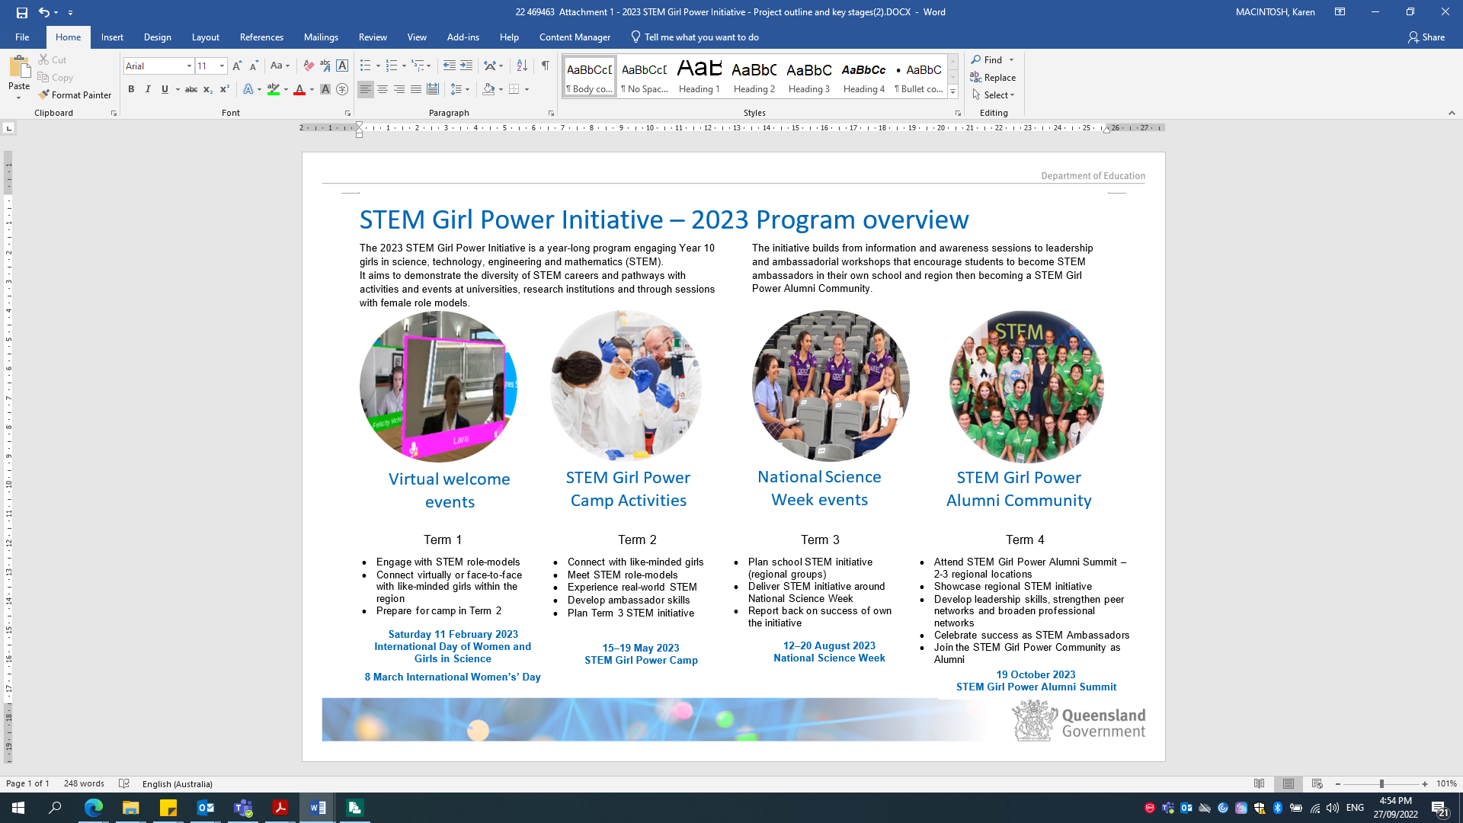The camp has expanded to a year-long program that includes online guest speaker sessions (Term 1), the camp (Term 2), regional activities for National Science Week (Term 3) and an end-of-year celebration of student activities (Term 4). Students and teachers are expected to participate in all activities during the year.

When and where will the STEM Girl Power Camp be held?

The STEM Girl Power Camp will be held from Monday 15 May to Friday 19 May 2023. Year 10 girls from across Queensland will travel to Brisbane for the evening welcome session on 15 May 2023.

Students will stay with teachers in supervised share accommodation at the [Queensland Conference and Camping Centre (QCCC)](https://www.qccc.org.au/discover-brookfield/) located in Brookfield which is approximately 15km out of Brisbane CBD for four nights from Monday 15 May to Thursday 18 May before returning home on Friday 19 May 2023.

Camp activities will take place at a number of locations in Brisbane including laboratories of universities and research institutions.

How much does it cost and how do students get there?

***There is no cost to schools or students to attend the STEM Girl Power Camp.***

Accommodation and meals will be provided. Camp organisers will coordinate travel arrangements to and from the camp with the parents or guardians of selected students and their school principal.

For students living in regional Queensland, travel to Brisbane will be arranged; however, the school, parent or guardian may need to organise part of the student’s travel, for instance to the regional airport or local transit centre.

Where a student lives within driving distance of Brisbane, the school and parent or guardian will be required to arrange student travel to the camp and advise the camp organisers.

What if an applicant has additional needs or requirements?

If an applicant is selected by the panel to participate in the camp and requires support, the camp organisers will contact the family, guardian and school to discuss the program and any specific student needs prior to camp.

How are applicants selected?

A panel of education and STEM professionals will select attendees from regions across Queensland. Selection will be based on assessment of each applicant’s responses.

Applications should be submitted through the [Entrant Portal](https://e-award.com.au/2022/stemgirlpowercamp) by 5.00pm Thursday 27 October 2022. Instructions for submitting an application are on the next page.

|  |
| --- |
| **Only one student application is accepted from each Queensland state school.**  **Interested applicants should contact their school about their school’s selection processes.**  **Principals will receive an email with an application link or teachers can contact** [**stem@qed.qld.gov.au**](mailto:stem@qed.qld.gov.au) **for information.** |

Important dates and use of personal information:

Applications close at ***5.00 pm on Thursday 27 October 2022.***

Successful applicants will be notified ***by the end of Term 4 2022.***

For further information about the STEM Girl Power Camp please email [stem@qed.qld.gov.au](mailto:stem@qed.qld.gov.au) or go to the Department’s public STEM [hub](https://learningplace.eq.edu.au/cx/resources/file/5da759ed-285d-4132-b8e8-58198109fb03/1/html/girl-power.html) page:

A student information form is included in the online application process for planning purposes. A student’s parent or guardian will be asked to complete additional permission and consent forms for camp activities if the application is successful. Camp coordinators do not have access to OneSchool and will require a parent or guardian to provide relevant student health information.

The Department of Education (DoE), through State Schools Division, is collecting your personal information for the purposes of assessing/contacting applicants and for organising and planning the 2023 STEM Girl Power Camp and STEM Girl Power Initiative activities during the year. The information will only be accessed by DoE staff administering the 2023 STEM Girl Power Initiative and in some cases, authorised community and/or Department representatives assisting DoE in the selection of participants. Successful applicants’ information will be disclosed to the STEM Girl Power Initiative organisers, travel providers and external program operators (for example laboratory session managers) for planning and administration of camp organisation and activities or STEM Girl Power Initiative activities during the year. Your information will not be used by, or disclosed to any other person or entity unless we have your consent, or DoE is required or authorised by law to do so.

**Instructions for applying**

All forms can be accessed from the [Entrant Portal](https://e-award.com.au/2022/stemgirlpowercamp). Once completed all forms and attachments need to be uploaded onto the Entrant Portal to finalise the application.

|  |
| --- |
| 1. The school is to nominate one female student enrolled in Year 9 in 2023 (Year 10 in 2023) to attend the camp. A teacher can register the student’s details and principal contact email through the [Entrant Portal](https://e-award.com.au/2022/stemgirlpowercamp). 2. The student will receive an email inviting them to complete their application through the Entrant Portal. ***\*Check your other email folders if not received in the inbox.*** 3. ***The student completes their online application by*** responding to these four questions and providing examples to support their application:    1. What interests you about STEM? (maximum 300 words)    2. What role does STEM play in your life? (maximum 300 words)    3. Outline your involvement in activities beyond normal school attendance (clubs, teams, competitions) (maximum 300 words)    4. What is the impact these activities have on your class, school or community. (maximum 300 words)    * You can upload electronic copies of any documents that support your application (for example, award certificate for a competition, name and date of a local event, media or newsletter items featuring your participation in STEM events). 4. The principal will receive an email inviting them to endorse and complete the student’s application. ***The school finalises the student application by***:    1. providing (uploading) evidence of the student’s academic achievement (attach a list of the student’s achievement in Year 8 and Semester 1 Year 9 subjects).    2. providing a principal’s endorsement and statement of support for the student’s application to the STEM Girl Power Camp which describes:       * the student’s engagement and participation in STEM-related activities; and       * the student’s personal qualities that will support them to be a STEM ambassador. (maximum 300 words)    3. finalising the student’s application in the Entrant Portal. 5. Upon submission of the completed application, the student and the principal will receive a confirmation email. |

The Department of Education (DoE), through State Schools Division, is collecting your personal information for the purposes of assessing/contacting applicants and for organising and planning the 2023 STEM Girl Power Camp and STEM Girl Power Initiative activities during the year. The information will only be accessed by DoE staff administering the 2023 STEM Girl Power Initiative and in some cases, authorised community and/or Department representatives assisting DoE in the selection of participants. Successful applicants’ information will be disclosed to the STEM Girl Power Initiative organisers, travel providers and external program operators (for example laboratory session managers) for planning and administration of camp organisation and activities or STEM Girl Power Initiative activities during the year. Your information will not be used by, or disclosed to any other person or entity unless we have your consent, or DoE is required or authorised by law to do so.