# 

# **2023 STEM Girl Power Camp – Teacher Applications**

# Frequently asked questions (FAQs) and Instructions for applying

The study and practice of science, technology, engineering and mathematics is collectively known as STEM. The STEM Girl Power Camp is an initiative of *Advancing education: An action plan for education in Queensland*. The camp aims to encourage girls to participate in STEM by engaging Year 10 girls in a range of exciting STEM experiences. The girls are also invited to be a STEM ambassador at their school and to inspire other students.

The seventh annual STEM Girl Power Camp will be held in Brisbane from 16-19 May 2023. The camp will bring together Year 10 girls from across Queensland who show high achievement in STEM-related subjects at school and an active interest in their school community.

Up to 60 students will be invited to the STEM Girl Power Camp in 2023 from across Queensland’s seven regions. Teachers with a passion for STEM are invited to apply to be regional camp leaders travelling with and supervising students and participating at the camp.

# STEM Girl Power initiative – Year long program

The STEM Girl Power Camp has grown into an initiative that is a year-long program that includes online guest speaker sessions (Term 1), the camp (Term 2), regional activities for National Science Week (Term 3) and an end-of-year celebration of student activities (Term 4).

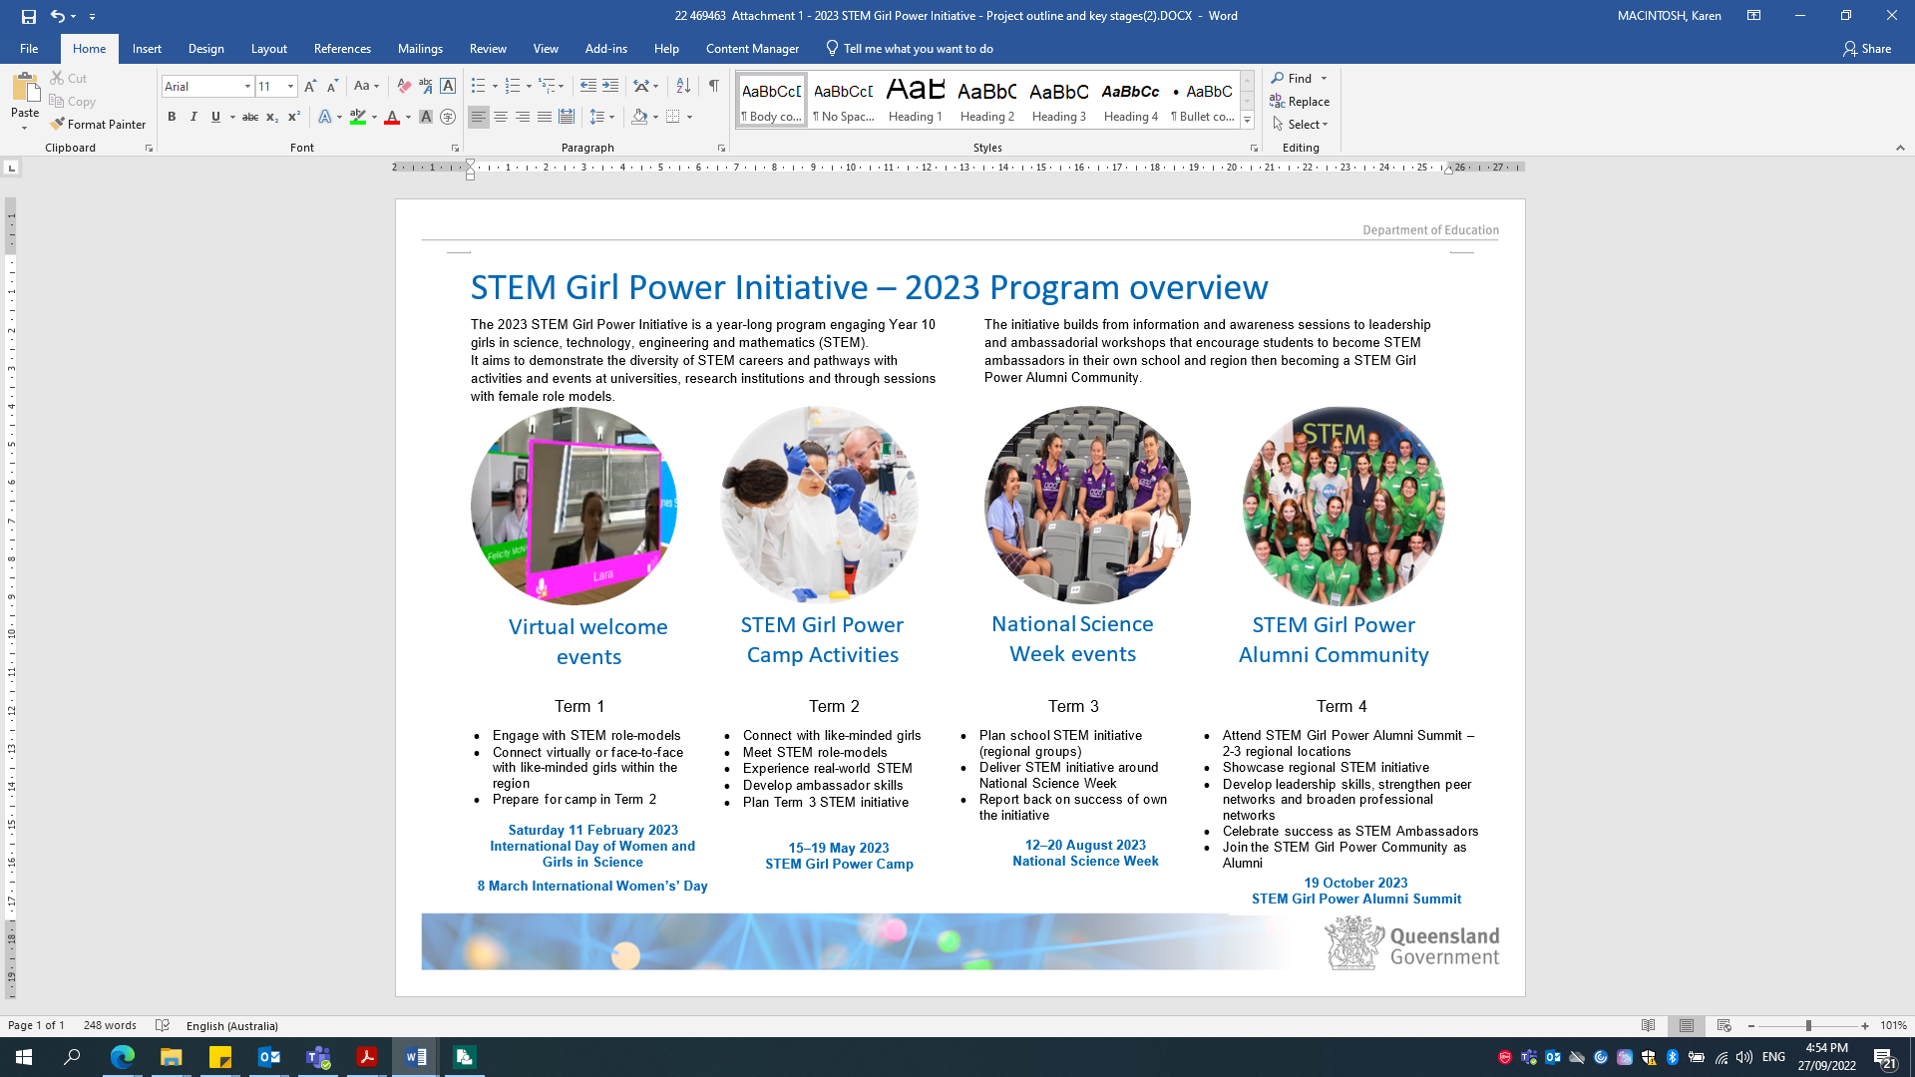

# *What are the obligations for teacher participants?*

**Before the STEM Girl Power Camp**

Teachers will be required to complete the STEM Girl Power Camp Project Consent Forms as part of your acceptance for attending the camp. The project consent forms will outline the activities planned for the camp. In Term 1 and Term 2 teachers will be invited to attend online sessions to connect with students, the camp team and regional contacts.

In the lead up to camp, you will be required to attend teleconferences providing updates on camp planning and information relevant to students attending from your region.

Teachers will be expected to chaperone a group of students from your region during their travel to camp and may be required to make direct contact with students before travel. You will be provided with any relevant health information for the students in your care.

**During the STEM Girl Power Camp**

Teachers will supervise the students as they participate in a number of site visits and activities. Teachers will remain with their camp group during this time and provide rostered overnight supervision with other regional teachers while on-site at the accommodation.

Teachers are to chaperone and provide pastoral care for their regional students and report any student issues to the Department’s camp coordinators who will lead the camp.

**After the STEM Girl Power Camp**

Teachers will be expected to chaperone a group of students from your region during their travel home from camp including ensuring students are transported to a pre-set location and met by their guardian. Teachers may need to participate in post-camp briefings.

It is intended that students attending the STEM Girl Power Camp will be STEM ambassadors when they return to school. Students will be invited to lead or participate in science activities in 2023, for example to promote National Science Week (Term 3). Regional officers will work with the students and their schools to organise events and will contact camp teachers to support, participate in and attend regional events during the year (Term 3 or 4). Teachers may also be asked to attend additional professional development sessions in Brisbane or regional centres and to support students at the end of year summit (Term 4).

# When and where will the STEM Girl Power Camp be held?

The STEM Girl Power Camp will be held from Monday 15 May 2023 to Friday 19 May 2023 with a welcome session on the evening of Monday 15 May 2023.

Teachers will stay on-site to supervise students in share accommodation at the [Queensland Conference and Camping Centres (QCCC)](https://www.qccc.org.au/discover-brookfield/) located in Brookfield, around 15km from Brisbane CBD, for four nights from Monday 15 May to Thursday 18 May before returning home on Friday 19 May 2023.

Camp activities will take place at a number of locations in Brisbane including laboratories of universities and research institutions.

# How much does it cost and how do teachers get there?

***There is no cost to the school for a teacher to participate in the camp.***

Travel, accommodation, catering and costs of events and activities will be paid for by the Department of Education. If required, the teacher’s school will be provided with five days of Teaching Relief Scheme (TRS) payment for the school days the teacher is at camp (Monday 15 to Friday 19 May 2023).

Depending on student numbers, at least one teacher from each region will be invited to accompany the students and provide pastoral care and supervision of students at day and night camp activities.

Depending on location, the teacher may be required to accompany a number of regional students by plane or bus to and from Brisbane, or meet students at pre-determined locations and be responsible for their supervision. Teachers located within a three hour drive of Brisbane will be expected to organise their travel to camp if not supervising travelling students.

# Important dates and use of personal information

Applications close at ***5.00 pm on Thursday 27 October 2022.***

Successful teacher applicants and their principal will be notified ***by the end of Term 4 2022.***

Teachers will be asked to confirm their intention to attend and provide initiation information for camp planning ***before the end of Term 4 2022.***

Teachers are expected to attend one of the Term 1 2023 welcome sessions for students.

In ***April 2023*** an information package with the camp program and activity permission forms will be sent to successful applicants to complete and supervising teachers will be provided with relevant travel and regional student information in April-May 2023.

For further information about the STEM Girl Power Camp please email [stem@qed.qld.gov.au](mailto:stem@qed.qld.gov.au) or go to the Department’s public STEM [hub](https://learningplace.eq.edu.au/cx/resources/file/5da759ed-285d-4132-b8e8-58198109fb03/1/html/girl-power.html) page:

A teacher information form is included in the online application process for planning purposes. Teachers selected for the camp will be asked to complete additional permission and consent forms for camp activities.

# What is the application process?

Completed applications (including attachments) are to be submitted through the [Entrant Portal](https://e-award.com.au/2022/stemgirlpowercamp) by ***5.00 pm on Thursday 27 October 2022.*** Instructions for submitting an application are provided at the end of this document.

Successful applicants will be advised of their selection by the end of Term 4 2022.

**Only one teacher application is accepted from each Queensland state school.**

*If multiple teacher applications are received from a school the principal will be asked to select the school’s nomination.*

**Interested applicants should contact their school about their school’s selection processes.**

**Principals will receive an email with an application link or teachers can contact**

**Privacy Statement:**

The Department of Education (DoE), through State Schools Division, is collecting your personal information for the purposes of assessing/contacting applicants and for organising and planning the 2023 STEM Girl Power Camp and STEM Girl Power Initiative activities during the year. The information will only be accessed by DoE staff administering the 2023 STEM Girl Power Initiative and in some cases, authorised community and/or Department representatives assisting DoE in the selection of participants. Successful applicants’ information will be disclosed to the STEM Girl Power Initiative organisers, travel providers and external program operators (for example laboratory session managers) for planning and administration of camp organisation and activities or STEM Girl Power Initiative activities during the year. Your information will not be used by, or disclosed to any other person or entity unless we have your consent, or DoE is required or authorised by law to do so.

**Instructions for applying**

All forms can be accessed from the [Entrant Portal](https://e-award.com.au/2022/stemgirlpowercamp). Once completed all forms and attachments need to be uploaded onto the Entrant Portal to finalise the application.

1. State schools in Queensland are invited to nominate a teacher to attend the camp. The principal will need to nominate and register the teacher. Click on the [Entrant Portal](https://e-award.com.au/2022/stemgirlpowercamp) and submit the teacher’s details.
2. The teacher will receive an email to access the Entrant Portal to complete their application. ***\*Check your other email folders if not received in the inbox.***
3. The teacher completes their online application by responding to these questions and providing examples to support their application:
   1. Describe their motivation for applying
      1. Why are you applying to participate in this program? (maximum 300 words)
      2. How do you envisage this camp will benefit you, your students and school community? Outline how you intend to build participation in STEM at your school on your return. (maximum 300 words)
      3. Outline previous experience chaperoning school or other groups indicating year, place, purpose and any challenges to manage. (maximum 300 words)
      4. Outline what you believe are key responsibilities for chaperones when accompanying students for camps and study tours. You may outline how you have undertaken the task previously. (maximum 300 words)
   2. You will be required to upload a teacher information form that will help with program planning if you are selected for the 2023 STEM Girl Power Camp.
   3. Applicants may wish to include a professional reference from an individual outside of the school as part of their application.
4. **The principal will receive an email** inviting them to endorse and complete the teacher’s application. ***The principal finalises the teacher application by:***
   1. providing a principal’s endorsement and statement of support for the teacher’s application (maximum 300 words) to the STEM Girl Power Camp which describes:
      * the teacher’s capabilities and support for STEM learning in their school and professional networks; and
      * the teacher’s personal qualities that will support them to be a STEM camp chaperone and STEM ambassador. (maximum 300 words)
      * finalising the teacher’s application in the Entrant Portal.
5. Upon submission of the completed application the teacher and the principal will receive a confirmation email.

Completed applications (including attachments) are due to be submitted on the [Entrant Portal](https://e-award.com.au/2022/stemgirlpowercamp) by ***5pm on Thursday 27 October 2022***.

For your application to be accepted you must meet the following terms and conditions

**TERMS AND CONDITIONS**

* This program is open for participation by Queensland state secondary school teachers only.
* Only one teacher may be nominated by each school.
* The selection panel may select participants based on departmental strategic priorities which may include distributing opportunities for travel throughout the Department’s service delivery regions.
* The selection panel may select participants with consideration of how many trips they have undertaken in the previous three years.
* The decision of the selection panel will be final. Feedback will be provided upon request.

**ELIGIBILITY**

To be eligible to apply as a leader for the 2023 STEM Girl Power Camp the applicant must:

* be a registered teacher in a Queensland state high school (or college, or academy);
* commit to STEM Girl Power Camp Initiative activities throughout the year.
* hold a current first aid certificate (copy of first aid certificate will be required);
* be in good health and fit for travel and camp activities (for example laboratory activities and walking between events);
* be prepared to abide by the [Queensland Code of Ethics for Teachers;](https://www.qct.edu.au/standards-and-conduct/code-of-ethics)
* be prepared to advise the Department of any changes that may affect participation (e.g. health, family or school requirements);
* be willing to participate in all activities arranged by the organisers;
* participate in pre-camp briefings; and
* be available to travel, supervise and stay overnight at accommodation with students from Monday 15 May 2023 – Friday 19 May 2023;